
We all need help every now and again and our goal in Data Operations is to get you that assistance as quickly as possible. With that though in mind we have two ways to get you help.
One – WE have partnered with Structured as our Managed Service Provider (MSP). They can address most issues that happen on your computer.
Two – Data Operations department
Sometimes it is hard to know who to contact. Below are examples and whom to contact.
Structured | Data Operations
Most everything dealing with Office 365  - Outlook (email issues)  - OneDrive  - Teams  - Word / Excel / Power Point / One Note  Operating system issues  - Computer locks up  - Starts running slow (not normal)  - Most issues with Windows desktop including windows updates  - Mysterious pop-us  Missing software  - Loss of SentinelOne icon  - Icons missing on the desktop  - Locating files that were downloaded  Network Printing  - Locally attached printers  - Network printers not using papercut (secure print) | Office 365 configuration questions  - Setting up a new resource calendar  - Multi-Factor Authentication (MFA)  - Calendar Polling / Bookings  LastPass  - Shared folders  - Turning on Family access  KnowBe4  - Access to previous years content  - Using the phishing reporting button  SmartSheet  - Access to the system. Sheet access is done by the sheet owner  VPN access  - Connecting to DL/BCT/CBS  - Needing to access another company  NISC  - Access or permissions  - BCT, CBS, CCMTC, DL  - Will assist with access to other companies NISC  Network Printing  - Working with Papercut (secure print)  Physical assistance  - Moving workstations to a new desk  - Credit card scanners  - Check scanners  - Mice / keyboard issues  - UPS not working

Contacting Structed is a two-step process.


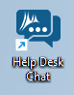
On your desktop there is a shortcut named “Help Desk Chat” Double clicking this icon will open your browser and provide you a form to fill out.


The form asks six questions. Once you have completed the from just click on the button on the bottom right “Initiate Chat”
- First name
- Last name
- Email
- Phone (recommend your office phone)
- Secondary phone (recommend your cell phone – or leave blank)
- Description (maximum length is 200 characters)
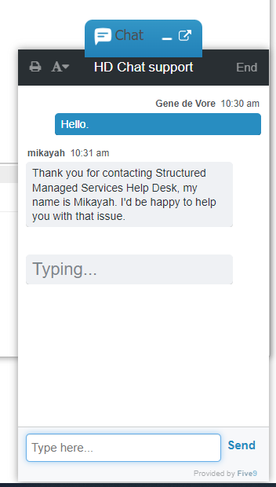

Once you initiate the chat a chat window will pop-up while a Structured support technician is found (normally less than 60 seconds)
Once the technician is online Structured can assist

NOTE

Any ticket that is opened with Structured is logged and copied to Data Ops. Data Ops then reviews these tickets with Structured bi-monthly. If you have a question that you originally started with structured, please provide Data Ops with the structured ticket number.

Contacting Data Operations is a one step process



Create a new email and describe your issue. Feel free to add screen shots etc.
Send this email to
DOhelp@cbsoregon.com

What does Data Operations do once I email them?
Data Operations will receive this email via Zendesk where Zendesk will assign you a ticket number and email you back, so you know that we have the ticket on file.
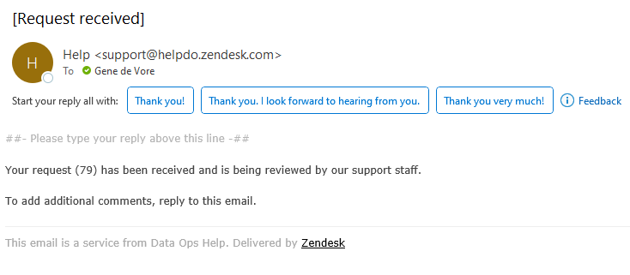
As we work the ticket you may receive updates via Zendesk (if we update notes etc.) and if you have additional information to add feel free to reply to the ticket.
NOTE

When you are replying to the trouble ticket email, the email address is automatically updated to support@helpdo.zendesk.com this is normal for interacting with Zendesk

